Microcontroller (1) Lab Manual

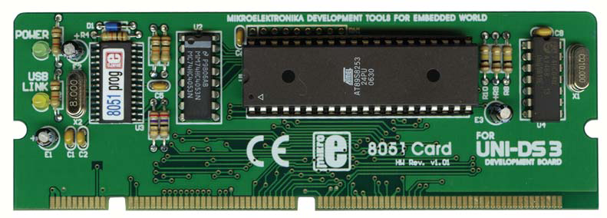
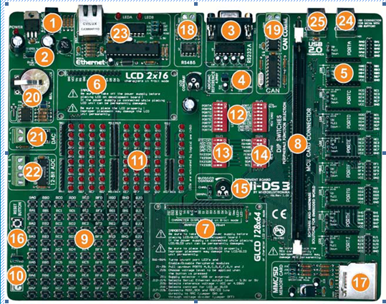
Prepared By:
Eng: Mohsen Ali AL-awami
Supervisered By:
Dr: Fadel AL-aqawa
2010-2011

ST University Course
Lab Contents

- Lab Experiment 1
- Leds Blinked
- Lab Experiment2
- Assembly Arithmetic’s and Logic operations
- Lab Experiment 3
- Assembly Blinky Using Timers
- Lab Experiment 4
- Timer Operations
- Lab Experiment 5
- Text LCD
- Lab Experiment 6
- Graphic LCD
- Lab Experiment 7
- Stepper Motor
- Lab Experiment 8Digital to Analog Converters
- Lab Experiment 9
- Analog to Digital Converters

Lab Experiment 1
Main Topics:
- Introduction to microcontrollers and embedded systems
- 8051 Atmel microcontrollers using assembly language
- Kiel and 8051 flash programs
- UNI-DS3 embedded system board
- Installing USB-Driver
- Explaining of 8051 Atmel microcontrollers chips
- Instructions sets
- Ledes blinking

Learning Objectives/Tasks:
Upon Compilation this experiment, you will be able to:

- Know what are microcontrollers and embedded systems
- Know how to use Kiel and 8051 flash programs and it’s purpose
- Know the UNI-DS3 kit
- List of registers of the 8051 microcontroller
- Manipulate data using the registers and mov instructions
- Detail the execution of assembly language instructions
- Know ports of microcontroller chip
- Write instruction sets
- Code of led blinking
UNI-DS3 KEY FEATURES
1.
External power supply from 8 to 16 V AC/DC;
2.
Choose between external and USB power
3.
RS232 communication port ;

supply. You don’t need an external supply if
you choose powering from PC’s USB port ;
4.
4.096V voltage reference is used for working
with A/D converter ;
5.
If you set jumper to the upper position the pins of appropriate port are set to logical one (pull-up). If you set jumper to the lower postion, the pins are set to logical zero (pull down). It is very important to select pull-up for
the port if you expect logical zero on it’s inputs
and vice versa ;

6.
You can connect LCD if you need it for your
application in 4-bit mode ;
7.
You can connect Graphic LCD if you need it
for your application or LCD in 8-bit mode ;
8.
MCU Card socket ;
9.
72 buttons enable you to control every pin on
your microcontroller ;
21.
D\A converter output ;
10.
You can choose how to affect a pin by pressing button, high
22.
A\D converter input ;
state or low state ;
23.
Serial Ethernet on board ;
11.
See all the signals - each pin has an LED ;
24.
USB connector for MCUs with USB support ;
12.
All switches on SW1 and switch 1 on SW2 are used to turn
25.
USB connector for USB 2.0 programmer ;
LEDs on all MCU ports ON or OFF. Switches 2, 3, 4 and 5 on
SW2 are used to enable Serial Ethernet and switches 6, 7 and 8
are used to enable CAN communication ;
13.
Switch 1 on SW3 enables Real Time Clock Interrupt. Switches 2,
3 and 4 on SW2 are used to enable A\D and D\A modules.
Switches 5, 6, 7, and 8 on SW3 are used to enable RS232 com
mutilation ;
14.
Switches 1, 2 and 3 on SW2 are used to enable RS485 commu-
nication, switches 4, 5 and 6 to enable SPI communication lines
and switches 7 and 8 to enable Real Time Clock ;
15.
Set LCD contrast according to your display characteristics ;
16.
Reset circuit - if the reset button is pressed a hardware reset will
happen (MCU will start executing from the beginning) ;
17.
MMC/SD slot for multimedia cards with storage space up to 2GB;
18.
RS485 communication port ;
19.
CAN communication port ;
20.
Real Time Clock ;

Hardware Connections:

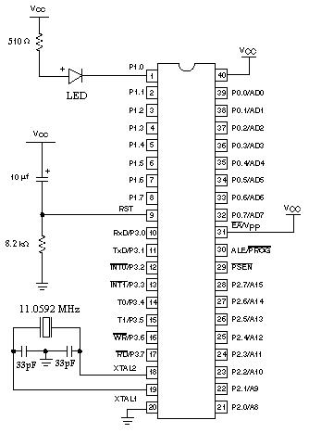

In this simple project demonstration, we will create a new project, write some code, compile
it with
and test the results. Our example will make LED diodes blink so it
keil version 4

can be easily tested on the 8051 microcontrollers.

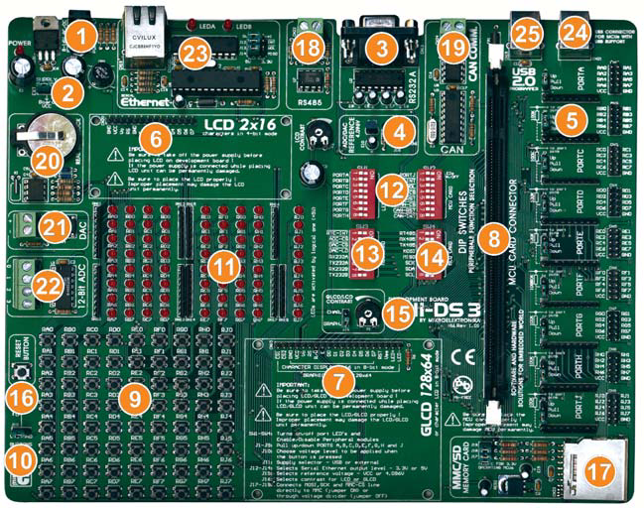
You will need the the connection scheme shown above to test the code for the 8051 micro-
controller. LED diodes are connected to Port P0. In this example you can use any other port
because this simple program will change the state of all ports in the same way. Prior to start, you have to go through the three basic steps.

Step 1: Install the compiler

Install the
Keil version4 compiler. Desktop shorcut and start menu shortcuts will be created

Step 2: Run the compiler

Run the Kiel version4 compiler. The Kiel vesion4 will appear

Step 3: create a new project

The easiest way to create a project is by means of the NEW PROJECT

Wizard drop-down menu >>> project >>>> new project or by clicking

The icon (new project) from project toolbar

As shown in the (fig.1)

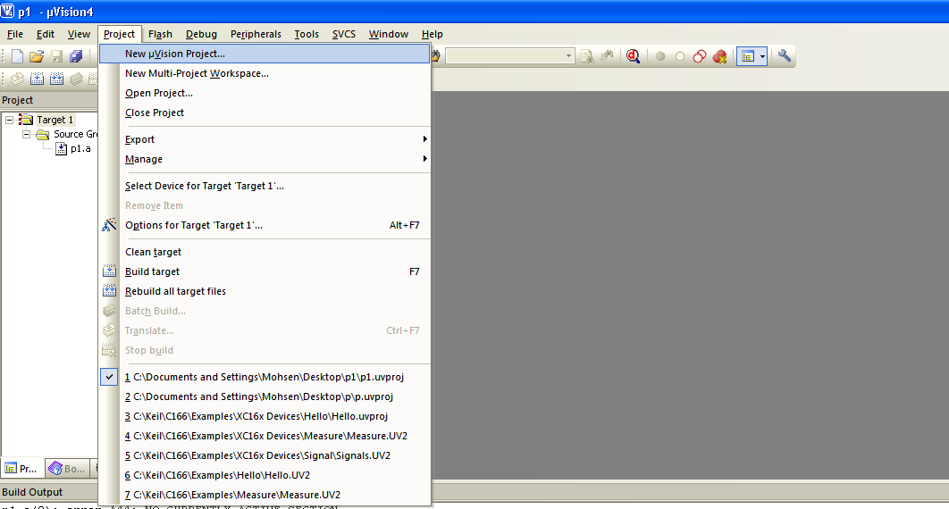fig.1
Step4 : New project wizard steps
The first window provides basic information on the project setting which will be applied in the following steps , write file name (e.g first project ) and select file type (.uv2proj)then click OK
As shown in the (fig.2)

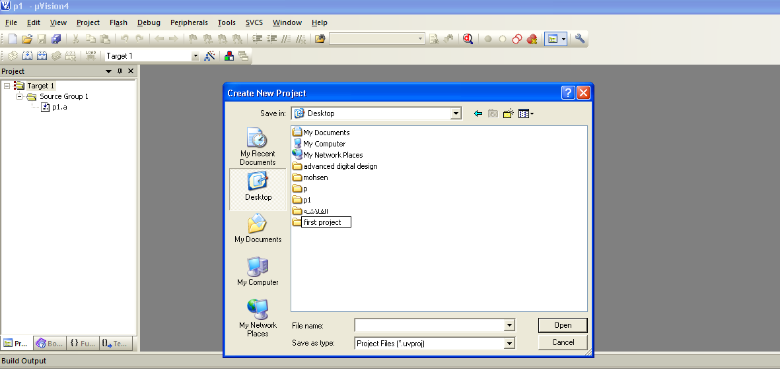
Fig.2

Then : in Fig.3

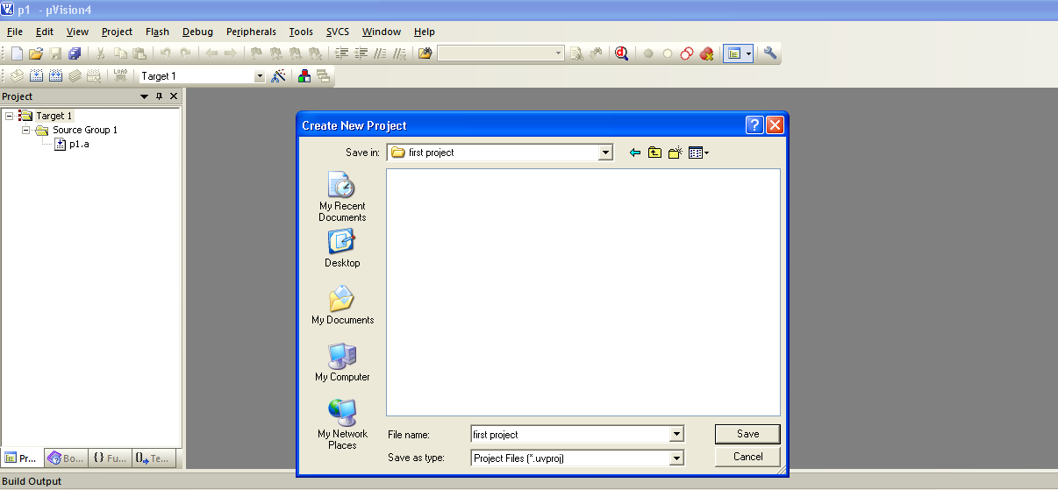

Fig.3

Step5:
Save and then :
From the device menu select a device for target and choose the suitable data base then click OK .
(as shown in Fig-4)

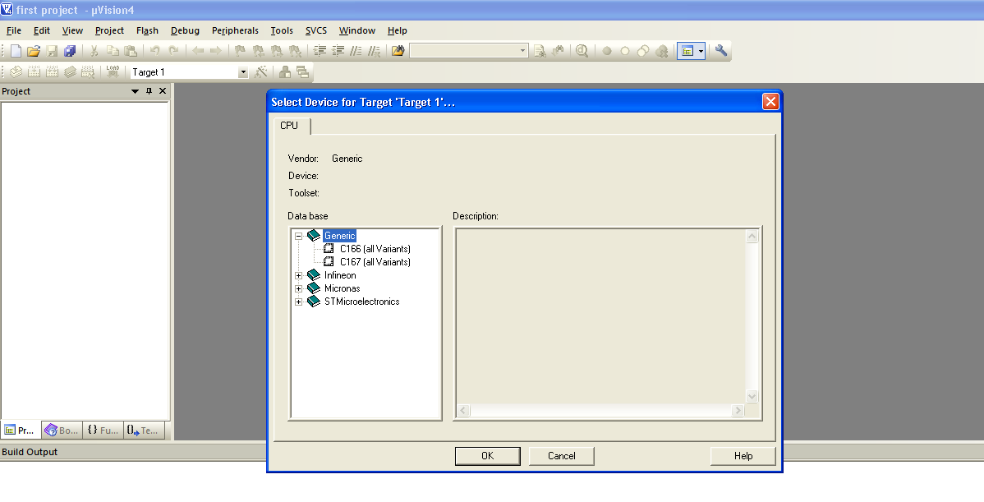
Fig-4
Step6:
Click on the sourec group then click on the new file and save it as assembly ,C,OOP types.
(As shown Fig-5)

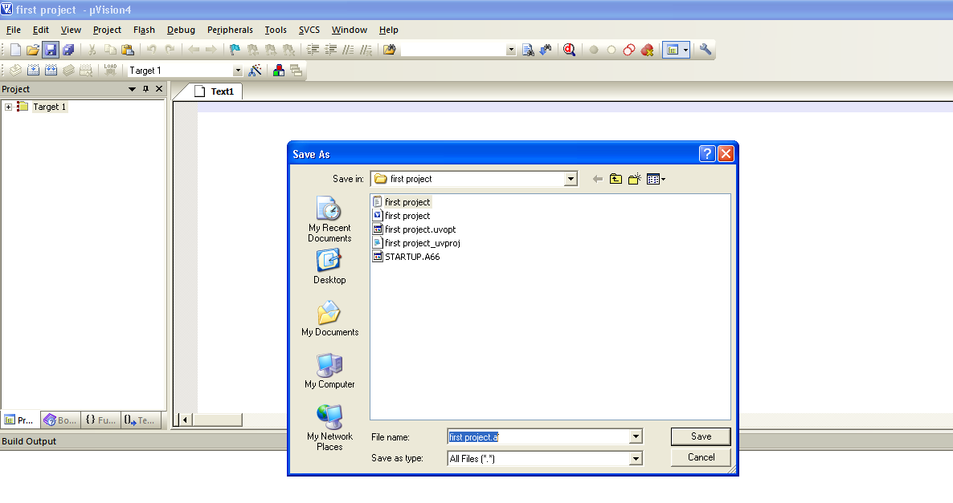
Fig-5
Step7 :
Right click on source group then choose (Add files to source group)
As shown in Fig-6

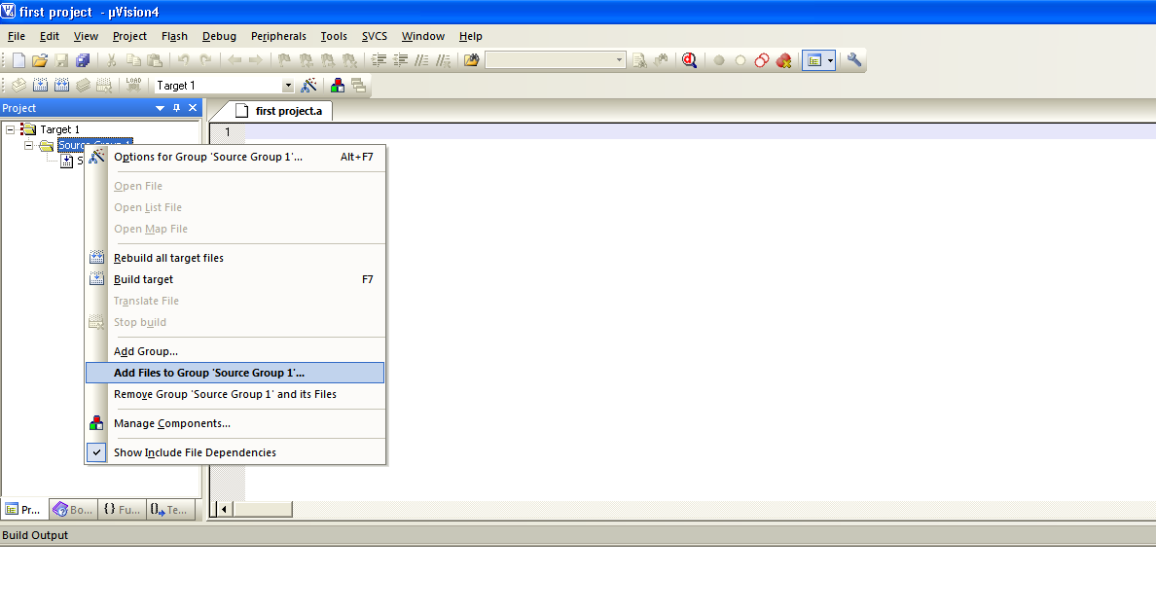
Fig-6
Step7:
The (add files to source group) menu will appear after that choose the file type and write the file name (a.c……act),then click add then close.
As shown on the fig-7

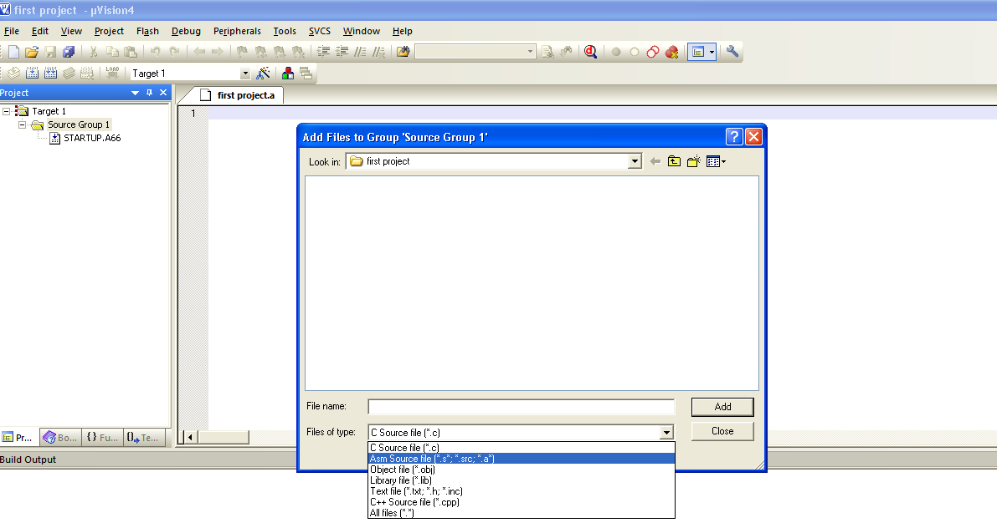
Fig-7

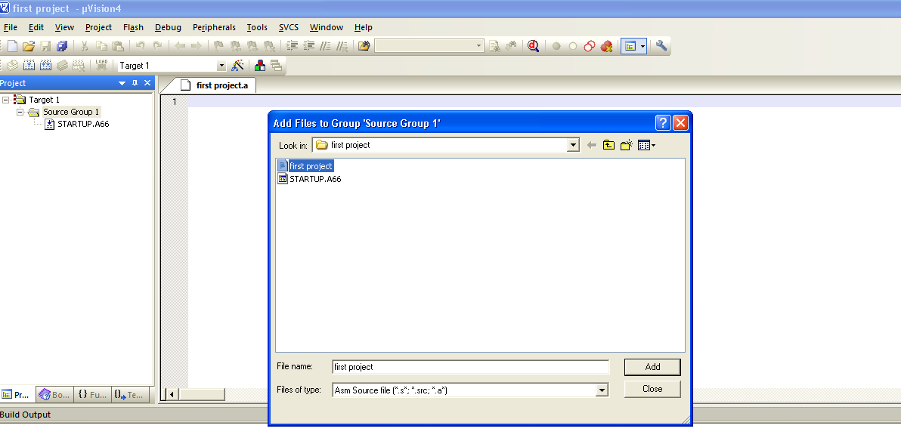
Fig-8

Step8:
To create HEX file right click on the target bar then choose (options for target’target 1’),the following menue will appear ;select on create hex file box then click OK,as shown in fig-9 & fig-10

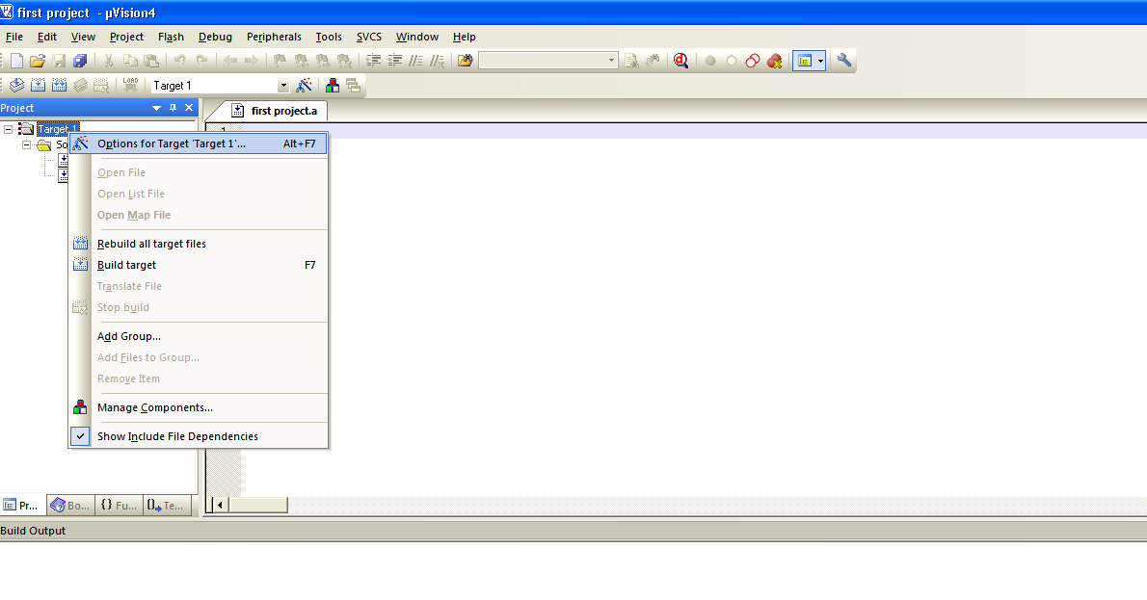
fig-9

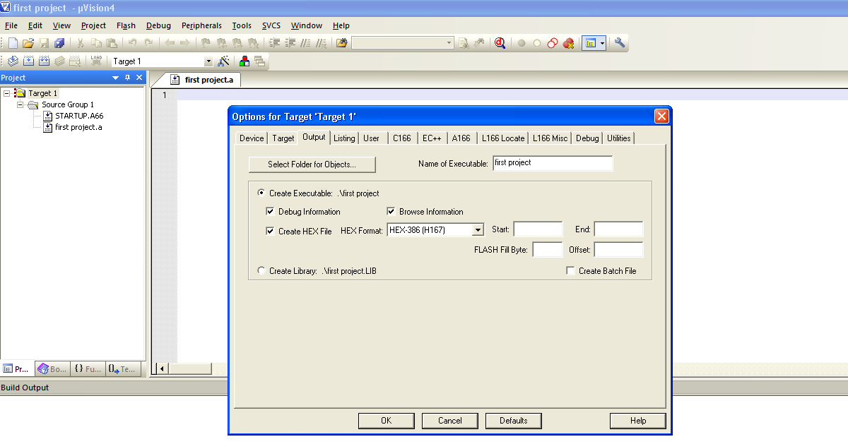
Fig-10

Now you can write the code

