A distinct placenta microbiome is detected in a multi-ethnic maternal obesity cohort

Paula A. Benny^{1#}, Fadhl M. Al-Akwaa^{1#}, Ryan J. Schlueter², Thomas K. Wolfgruber¹, Ingrid Y. Chern², Shaw J. Chun¹, Corbin Dirkx (?), Lana X. Garmire^{1,2*}

¹University of Hawaii Cancer Center, 701 Ilalo Street, Honolulu, HI 96813, USA
²Department of Obstetrics and Gynaecology, University of Hawaii, 1319 Punahou Street, Honolulu, HI 96826, USA
#These authors contributed equally to the work done
*Corresponding author: Lana X. Garmire, LGarmire@cc.hawaii.edu

Abstract
The human microbiome consists of approximately 39 trillion bacteria cells which inhabit several bodily surfaces including the skin and gut. Certain bacteria have a well-established role in the human body and are required for normal physiological functions. Dysbiosis has recently been associated with certain diseases. The placenta, once thought to be a sterile organ, has also been reported to have a unique microbiome and placental dysbiosis has been associated with certain medical conditions including pre-term birth. In this study, we examined the placental microbiome in a multi-ethnic maternal obesity cohort. It was confirmed that there was a distinct placenta microbiome and that the fetus does not develop in a sterile environment. The placenta, in general, had a predominantly Lactobacillus, Enterococcus and Chryseobacterium microbial landscape. At the genus level, the placenta microbiome of obese and non-obese mothers were similar. Within different regions of the placenta, we observed differing bacterial species. In particular the fetal surface of the placenta had lesser bacterial species as compared to the maternal or intermediate placenta surface, suggesting a placenta microbiome gradient. We have also developed an optimized microbiome protocol for the study of low bacterial biomass samples, such as the placenta.

Introduction
The human microbiome is the collection of microorganisms which reside on or in human organs. Symbiosis, for example in reference to gut bacteria, allows for the digestion of certain types of food which we otherwise would not be able to digest. Dysbiosis is the imbalance of the human microbiome and it has recently been associated with certain diseases including diabetes [1]. Dysbiosis has also been associated with pre-term birth [2-4].
Recently, Aagaard et al [5] showed the presence of a placenta microbiome. Before this landmark discovery, the placenta was thought to be a sterile organ. Since then, several groups have continued probing into the placenta microbiome [6, 7]. Interestingly, Lauder et al [8] refuted this discovery citing the lack of contamination controls in the Aagaard study. The authors explained that the bacteria detected in the Aagaard study was merely due to contaminations from the environment or reagents.
In light of the debate in the field, we embarked on three main aims. First, to elucidate the presence or absence of a placenta microbiome, we developed an optimized protocol which included the sequencing of several controls, including delivery room airswabs, laboratory airswabs and unopened reagents. We targeted mothers undergoing caesarean sections to eliminate other potential sources of bacteria contamination associated with a vaginal birth. Second, we profiled mothers of obese and non-obese pre-pregnancy BMI to determine the association between obesity status and microbiome profiles. Thirdly, to increase the resolution of our microbiome study, we sequenced three different regions of the placenta (maternal side, fetal side and intermediate side) to determine if there is a microbiome gradient within the placenta.

Materials and Methods
Sample collection: Placenta samples were collected from pregnant mothers admitted for Caesarean section surgeries at Kapiolani Medical Center for Women and Children, Honolulu, HI from November 2016 through September 2017. The study was approved by the Western IRB board (WIRB Protocol 20151223). To avoid the introduction of other bacteria associated with vaginal births, we recruited women scheduled for full-term cesarean section at ≥ 37 weeks gestation. Patients meeting inclusion criteria were identified from pre-admission medical records with pre-pregnancy BMI ≥30.0 (obese) or 18.5-25.0 (non-obese). Women with preterm rupture of membranes (PROM), labor, multiple gestations, pre-gestational diabetes, hypertensive disorders, cigarette smokers, HIV, HBV, and chronic drug users were excluded. Demographic and clinical characteristics were recorded, including maternal and paternal age, maternal and paternal ethinicities, mother’s pre-pregnancy BMI, net weight gain, gestational age, parity, gravidity and ethnicity. Placenta samples were obtained equidistance from the cord insertion site and the placenta edge. Placenta samples were isolated (0.5cm³) from the maternal, fetal and intermediate surface using sterile surgicals. Airswab samples were obtained by waving the airswab in the air in the room where the placenta biopsies were collected (beside the labor and delivery room) and from the research laboratory where extraction was carried out. Unopened airswabs were also collected.
Extraction of genetic material: MOBIO Powersoil DNA Kit (#12888-50) was used to extract DNA from placenta samples. 300mg of placenta was homogenized, heated for 65°C and vortexed in a horizontal bead beater for 10 minutes. DNA was extracted from lysates by putting them through the MOBIO kit following the manufacturer’s protocol. Extracted DNA was quantified using Nanodrop.
Enrichment, amplification and 16S sequencing: qPCR was performed to determine 16S counts within extracted samples. Next, to remove host DNA contamination and improve 16S specific amplification, an enrichment step was performed first (NEBNext Microbiome DNA Enrichment Kit, # E2612L). Samples were enriched in sets of 8 for optimal enrichment of bacterial DNA. DNAs were incubated with NEBNext magnetic beads for 15 minutes. Beads containing human host DNA were isolated using a magnet leaving microbial DNA in the supernatant. Isolated microbial DNA was amplified using primers to the hypervariable V4 region of 16S rRNA gene. Forward primer – TCGTCGGCAGCGTCAGATGTGTATAA GAGACAGGTGCCAGCMGCCGCGGTAA. Reverse primer – GTCTCGTGGGCTCG GAGATGTGTATAAGAGACAGGGACTACHVG GGTWTCTAAT. PCR was performed using KAPA HiFidelity Hot Start Polymerase; 95°C for 5 mins, 98°C for 20s, 55°C for 15s, 72°C for 1 minute for 25 cycles, 72°C for 5 minutes. After 25 cycles of amplification, V4 specific amplicons were observed as evidenced by 2% agarose gels and Agilent Bioanalyzer traces. V4 amplicon was detected at the expected size of 290bp. Samples were pooled, size-selected and denatured with NaOH, diluted to 8pM in Illumina’s HT1 buffer, spiked with 20% PhiX, and heat denatured at 96°C for 2 minutes immediately prior to loading. A MiSeq600 cycle v3 kit was used to sequence the samples.
Bioinformatic analysis: The 16S rRNA gene reads were analyzed using the pipeline shown in Supplementary Figure 1. Reads were stitched using Pandaseq [ref] using 150 and 350 as minimum and maximum length of the assembled reads respectively. Operational taxonomic units (OTUs) were created by clustering the reads at 97 % identity using UCLUST [ref]. Representative sequences from each OTU were aligned using PyNAST [ref], and a phylogenetic tree was inferred using FastTree v. 2.1.3 [ref] after applying the standard Lane mask for 16S rRNA gene sequences [ref]. Pairwise UniFrac distances were computed using QIIME [ref], and permutational tests of distance and principal coordinates analyses were performed with using the MicrobiomeAnalyst, a web-based tool for comprehensive exploratory analysis of microbiome [ref]. Taxonomic assignments were generated by the UCLUST consensus method of QIIME 1.9 [ref], using the GreenGenes 16S rRNA gene database v. 13_8 [ref]. The entire workflow from sample collection to data analysis is summarized in Figure 1.

Results
Demographic and clinical characteristics of the cohort
Our cohort consisted of three ethnic groups including Caucasian, Asian and Native Hawaiians. Women undergoing scheduled cesarean delivery were included based on the previously described inclusion and exclusion criteria (Methods section). Demographical and clinical characteristics in obese and control groups are summarized in Table 1. In the Caucasian group (12 mothers), 7 were categorized as non-obese and 5 as obese. In the Asian group (16 mothers), 8 were categorized as non-obese and 8 as obese. In the Native Hawaiian group (16 mothers), 3 were categorized as non-obese and 13 as obese. The variation in recruitment of cases versus controls in each ethnic background reflects the demographics in Hawaii. Compared to mothers of normal pre-pregnant BMI, obese mothers have significantly higher pre-pregnancy BMI, p<0.05. Mothers have no statistical difference regarding their ages, gestational weight gain or gestational age , p>0.05 excluding the possibility of confouding from these factors.
Investigating the placental microbiome
We first performed qPCR to determine the 16S copy numbers within extracted samples and found that placenta samples contained more copies of 16S as compared to airswab or water controls; placenta 73,595 mol/µl, airswab 83 mol/µl, water 24 mol/µl as shown in Figure 2A.
We removed contaminating human host DNA through an enrichment step. V4 and V1V3 primer sets were evaluated for 16S amplification efficiency in a subset of 8 samples (Figure 2 D). From these 8 samples, we found that V1V3 primers were not as efficient at amplifying 16S rRNA gene. Total number of reads of enriched V4 samples (median: 516,479) were more than from enriched V1V3 samples (median: 202,524) as shown in Figure 2B. Unenriched V4 samples yielded much lower total reads (median: 68,468) as compared to enriched V4 samples (median: 516,479). After sequence alignment of our reads using Greengenes database, the total number of operational taxonomic units (OTUs) of unenriched samples were very low (V4: 233, V1V3: 3) as shown in Figure 2C. OTU numbers from enriched samples using V1V3 was 414 which was also low. Interestingly, for enriched samples using V4 primers, 57,468 OTUs were detected. Therefore, we used a protocol incorporating an enrichment step (following extraction) and V4 primers for maximum 16S amplification efficiency for our cohort. On an agarose gel, V4 amplicons post-PCR amplification showed specific product size of 290bp, confirming successful 16S amplification of placenta samples and absence of V4 amplified product in negative controls (airswabs and water) as shown in Figure 2E.
In a PCA plot, we observed that airswabs and placental microbiome were indeed distinct and separable into two clusters as shown in Figure 3A. We calculated Bray-Curtis distances for the data pooled at the OTU level. The alpha diversity and difference between placenta and airswabs by T-test was p=0.054145 (Figure 3C). This data was also summarized in a box plot which shows a distinct placental microbiome from airswab controls (Figure 3B).
A heatmap representing the OTUs present in our cohort is presented in Figure 3D. Upon comparison of placenta samples with airswabs, there is a clear difference in bacteria detected as shown in the heatmap. In particular, 6 OTUs were predominantly found in air swabs only; 4479989; Streptococcus, 523025; Streptococcus, 341460; Haemophilus, 4477696; parainfluenzae, 3359884; Streptophyta, 4471279; Streptophyta. These OTUs are likely environmental contaminants and are not generally observed in the placenta samples. Rather, placenta samples contained 12 OTUs; 4425571; Enterobacteriaceae, 345362; Enterobacteriaceae, 289933; Lactobacillales, 3778553; Chryseobacterium, 4420570; Streptophyta, 563163; Ulvophyceae, 663718; Boronitolerans, 580342; Boronitolerans, 958496; Lactobacillus, 302975; Lactobacillus , 316515: Streptococcacaeae, 134726: Lactobacillus which were absent in airswabs. We observed 13 significantly different OTUs with FDR < 0.05 and plotted them in a series of bloxplots with emphasizing the original count and log-transformed count (Figure 4).
Next, we investigated the community structure by calculating the distance between all of the samples and interrogated the data for clustering associated with sample type. To determine the placenta community structure, we present a stacked bar chart of bacterial taxa as shown in Figure 5. At the genus level, placenta samples contain distinct microbiome populations as compared to airswabs. In particular, we observed that Chryseobacterium and Lactobacillus were found in placenta and not in airswabs. At the phylum level, Chryseobacterium and Lactobacillus are lineages from Bacteroidetes and Firmicutes respectively. Interestingly, our observation of Bacteroidetes and Firmicutes in the placenta, both commensal non-pathogenic bacteria, is in accordance with bacteria reported by the Baylor group [5].
Analysing placental microbiome from obese and non-obese mothers
Upon sub-classification of obese and non-obese samples within the placenta group, we found that there was lesser bacterial species composition and diversity in obese samples as compared to non-obese placenta samples. From the heatmap (Figure 3D), placentas from non-obese individuals had markedly more taxa and at a higher abundance (red; greater fold change) as compared to obese individuals, for example, 302975; Lactobacillus. It was observed that sample 66PI had particularly high bacterial biomass as compared to other samples, which could possibly indicate that this individual had an infection.
In a PCA plot, we observed that obese and non-obese placenta samples did not separate into two distinct clusters (Figure 6A). Interestingly, both cases and controls were in a separate cluster from airswabs. Next, we investigated the community structure by calculating the distance between all of the samples and interrogated the data for clustering associated with sample type. We calculated Bray-Curtis distances for the data pooled at the OTU level. The alpha diversity and difference between cases, controls and airswabs by ANOVA was p=0.15837 (Figure 6C; F-value=1.9154). This data was also summarized in a box plot which shows a distinct placental microbiome from airswab controls but which showed little difference between cases and control placentas (Figure 6B). At the genus level, the community structures of cases and controls were similar, with both containing similar bacterial taxa (Chryseobacterium, Enterococcus, Haemophilus, Lactobacillus, Lysinibacillus and Streptococcus) as shown in Figure 3D.
Analysing placental microbiome from different regions of the placenta
As we had also collected placenta samples from three different regions of the placenta, we next sub-classified the placenta group into placenta location (L1; maternal, L2; fetal, L3; interemediate surface). From a PCA plot (Figure 7A), we observed that samples of the maternal surface clustered tightly while samples of the fetal surface were in a larger cluster. Samples from the intermediate surface of the placenta were distributed in a pattern in between those observed for the maternal and fetal surface. It was also observed that all three placenta surfaces generally overlapped with each other, but not with the airswabs. A closer look into the community structure of the different placenta regions (Figure 7B) revealed that Gemellales species was completely absent at the fetal surface as compared to the other placenta surfaces. All other taxa were similar across placenta surfaces as shown in Figure 7B (Pasteurellales, Lactobacillus, Enterobacteriales, Bacillales, Streptophyta).

Discussion
To elucidate the presence or absence of a placenta microbiome, we performed targeted 16S sequencing of the V4 hypervariable region using an optimized protocol for low bacterial biomass samples. Unique to our protocol was the enrichment step which enriched for bacterial DNA and limited human host contamination. This revealed a quantifiable placenta microbiome signature which was distinct from contamination airswab controls.
In a test set of eight samples, we evaluated the efficiency of the enrichment step and different primer sets on 16S sequencing quality. In unenriched samples, we observed that the use of V1V3 primers initially produced more total number of reads as compared to the use of V4 primers. However, after alignment, there were very low numbers of OTUs indicating that most of the resultant reads could not be mapped to a bacterial database. In enriched samples, we observed a significant number of aligned OTUs using V4 primers over V1V3 primers indicating that the enrichment step was successful at eliminating host contamination and amplifying bacterial species. This optimized protocol was applied to our placenta maternal obesity cohort to (1) determine the existence of a unique placenta microbiome (2) determine if there is a differential placenta microbiome in obese and non-obese mothers (3) determine if there is a bacterial gradient within the placenta.
Using a robust bioinformatics pipeline on raw reads, we discovered that the placenta microbiome was distinct from airswabs. Upon analysis of the community structure of placenta and airswab samples, it was observed that the taxa contained within airswab samples were largely from airway taxa (Haemophilus, Streptococcus) and plant species (Streptophyta). Unique placenta taxa were Enterobacteriaceae, Lactobacillus and Chryseobacterium which are characterized as commensal non-pathogenic bacteria. Enterobacteriaceae are a type of proteobacteria which are gram negative symbionts usually found in the gut. Lactobacillus, a type of Firmicutes bacteria are gram positive and also found in the digestive system where they convert sugar to lactic acid. Chryseobacterium, from the Bacteroidetes family, is a type of gram negative bacteria typically found in milk. To limit the bacterial contamination associated with a vaginal birth, we obtained placenta samples from mothers who underwent caesarean section deliveries. Therefore, we are confident that the placenta bacteria observed in our study is unique to the placenta alone.
In the analysis of microbial species between placenta samples from obese and non-obese mothers, we found that the bacterial taxa are very similar. From the heatmap in Figure 3D, it appears that there may be lesser bacterial abundance and richness in obese samples as compared to non-obese samples. However, in a PCA plot, box plot and alpha diversity analysis (Figure 6), we observed that this was not statistically significant.
In the analysis of microbial species within different regions of the placenta, we observed that the Gemellales species was completely absent at the fetal surface, but was present at the maternal and intermediate surface. This suggests that bacteria may be “seeded” at the maternal surface and move through the placenta, passing the intermediate surface first before reaching the fetal surface and the developing fetus. Our observation is similar to that discussed previously [5, 9] wherein bacteria originates from the mother and then is passed on to the fetus.
The novelty of this study is (1) in utilizing an optimized enrichment protocol to study low bacterial biomass samples, such as the placenta (2) in studying a multi-ethnic cohort (3) analysing three different regions of the placenta. The strength of our study is (1) using contamination controls to account for any environmental contaminants (2) a robust bioinformatics pipeline to analyse read sequences.

Conclusion
We have shown for the first time, that a placenta microbiome does exist, using an optimized enrichment protocol for low bacterial biomass samples. Probing further into the placenta of obese and non-obese mothers, we found that their microbiomes were similar. Upon analysis of the different regions of the placenta, we found that there was a microbiome gradient with the fetal surface being the least populated with microbial species.

Author Contributions
LXG envisioned the project, obtained funding, designed and supervised the project and data analysis. RJS, IYC collected the samples. PAB, FMA, TKW and SC carried out the experiments and analysed the data. All authors have read, edited, revised and approved the manuscript.

Acknowledgements
Dr. Lana X Garmire’s research is supported by grants K01ES025434 awarded by NIEHS through funds provided by the trans-NIH Big Data to Knowledge (BD2K) initiative (http://datascience.nih.gov/bd2k), P20 COBRE GM103457 awarded by NIH/NIGMS, R01 LM012373 awarded by NLM, and R01 HD084633 awarded by NICHD to LX Garmire. Funding was also provided in part by the Department of Obstetrics and Gynecology, University of Hawaii. 16S sequencing was performed by The University of Minnesota Genomics Center.

Conflict of Interest
The authors disclose no conflict of interest exists.

References

1. Li, X., K. Watanabe, and I. Kimura, Gut Microbiota Dysbiosis Drives and Implies Novel Therapeutic Strategies for Diabetes Mellitus and Related Metabolic Diseases. Front Immunol, 2017. 8: p. 1882.
2. Antony, K.M., et al., The preterm placental microbiome varies in association with excess maternal gestational weight gain. Am J Obstet Gynecol, 2015. 212(5): p. 653 e1-16.
3. Prince, A.L., et al., The placental membrane microbiome is altered among subjects with spontaneous preterm birth with and without chorioamnionitis. Am J Obstet Gynecol, 2016. 214(5): p. 627 e1-627 e16.
4. Doyle, R.M., et al., Term and preterm labour are associated with distinct microbial community structures in placental membranes which are independent of mode of delivery. Placenta, 2014. 35(12): p. 1099-101.
5. Aagaard, K., et al., The placenta harbors a unique microbiome. Sci Transl Med, 2014. 6(237): p. 237ra65.
6. Zheng, J., et al., The Placental Microbiome Varies in Association with Low Birth Weight in Full-Term Neonates. Nutrients, 2015. 7(8): p. 6924-37.
7. Jones, H.E., et al., Differing prevalence and diversity of bacterial species in fetal membranes from very preterm and term labor. PLoS One, 2009. 4(12): p. e8205.
8. Lauder, A.P., et al., Comparison of placenta samples with contamination controls does not provide evidence for a distinct placenta microbiota. Microbiome, 2016. 4(1): p. 29.
9. Nature Medicine volume 23, pages 314–326 (2017)

Figure 1: Workflow of microbiome study, from sample collection to data analysis.

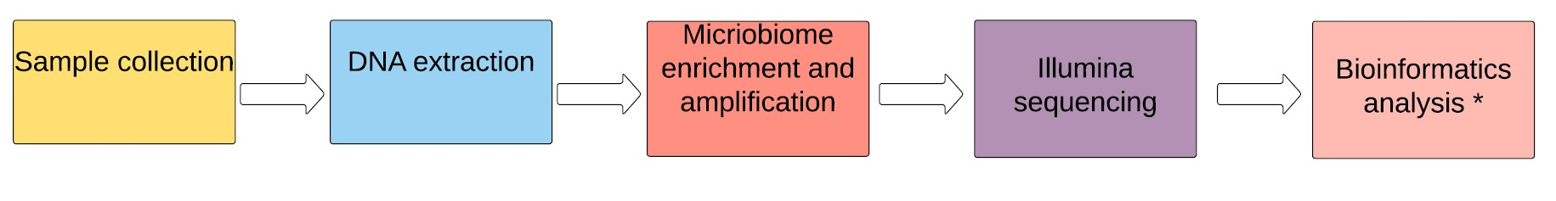

Table 1: Clinical characteristics of the cohort.

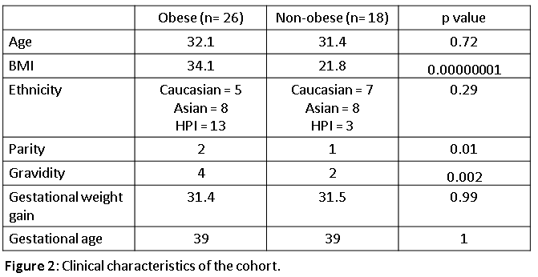

Figure 2: (A) 16S counts of placenta and controls (airswabs and water) using qPCR. (B) Total number of reads in enriched and unenriched samples while varying primer types. (C) Total number of counts per sample (after alignment to Greengenes database) in enriched and unenriched samples. (D) qPCR analysis to justify the need for a microbial enrichment step and using V4 primers during the amplification step. (E) Agarose gel run showing specific V4 amplicon (290bp) detected in placenta samples which are not present in airswab or water controls.

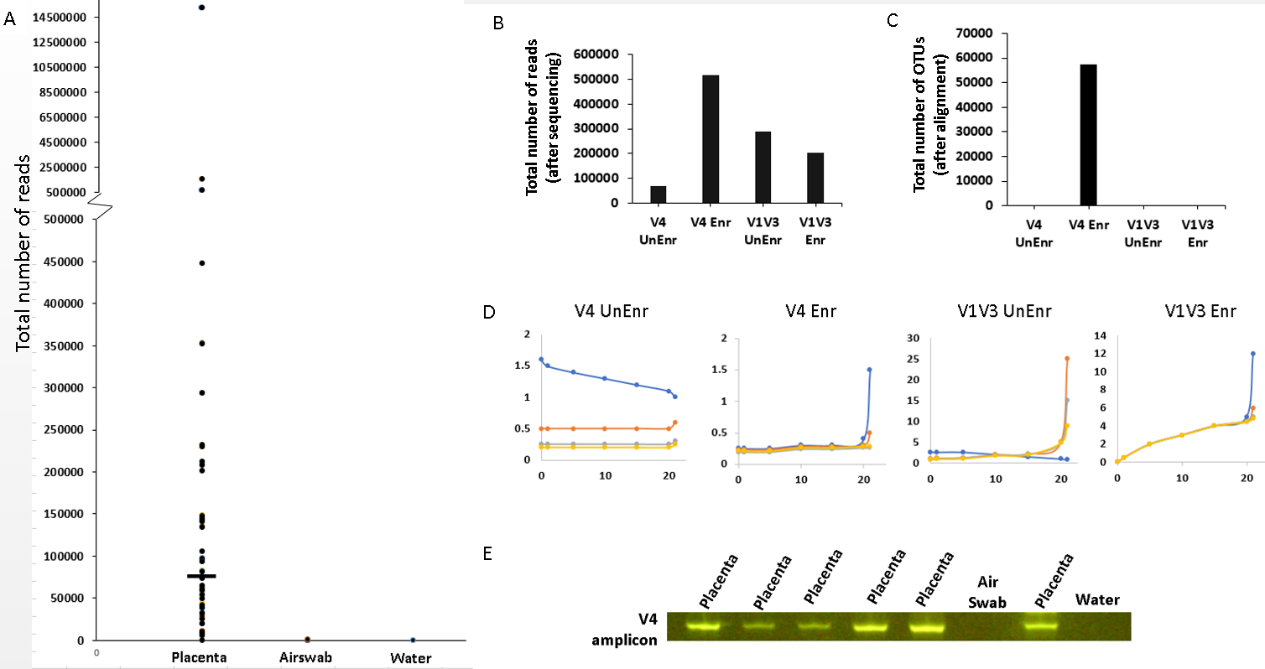

Figure 3: (A) PCA of placenta and airswab clusters. (B) Boxplot summarizing the OTU diversity in placenta and airswabs (C) Alpha diversity (T-test, p=0.054145) (D) Heatmap showing different OTUs in placenta samples and airswabs (B) PCA showing two clusters (placenta and airswab)
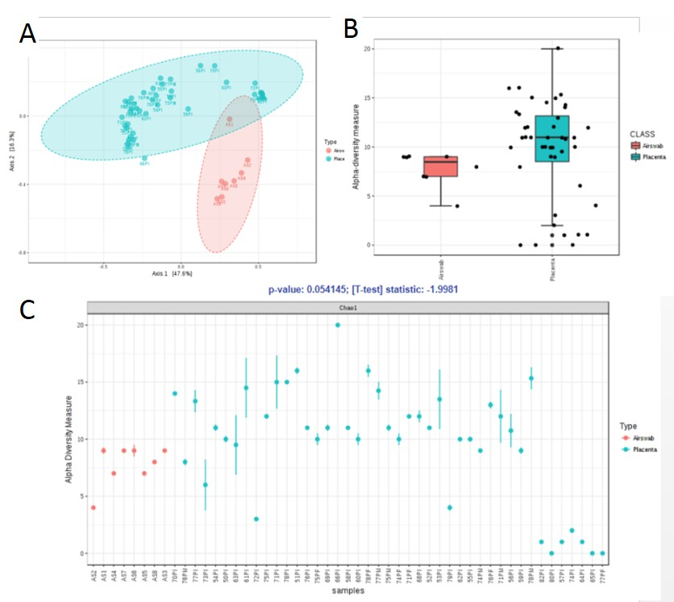

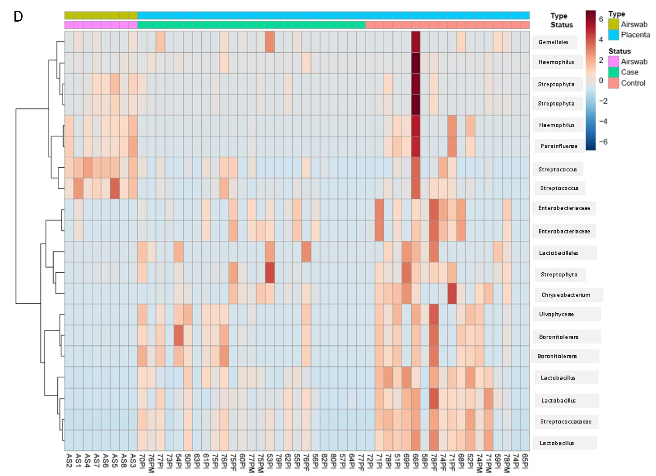

Figure 4: 6 out of the 13 significantly different OTUs when comparing placenta and airswab samples (FDR < 0.05)
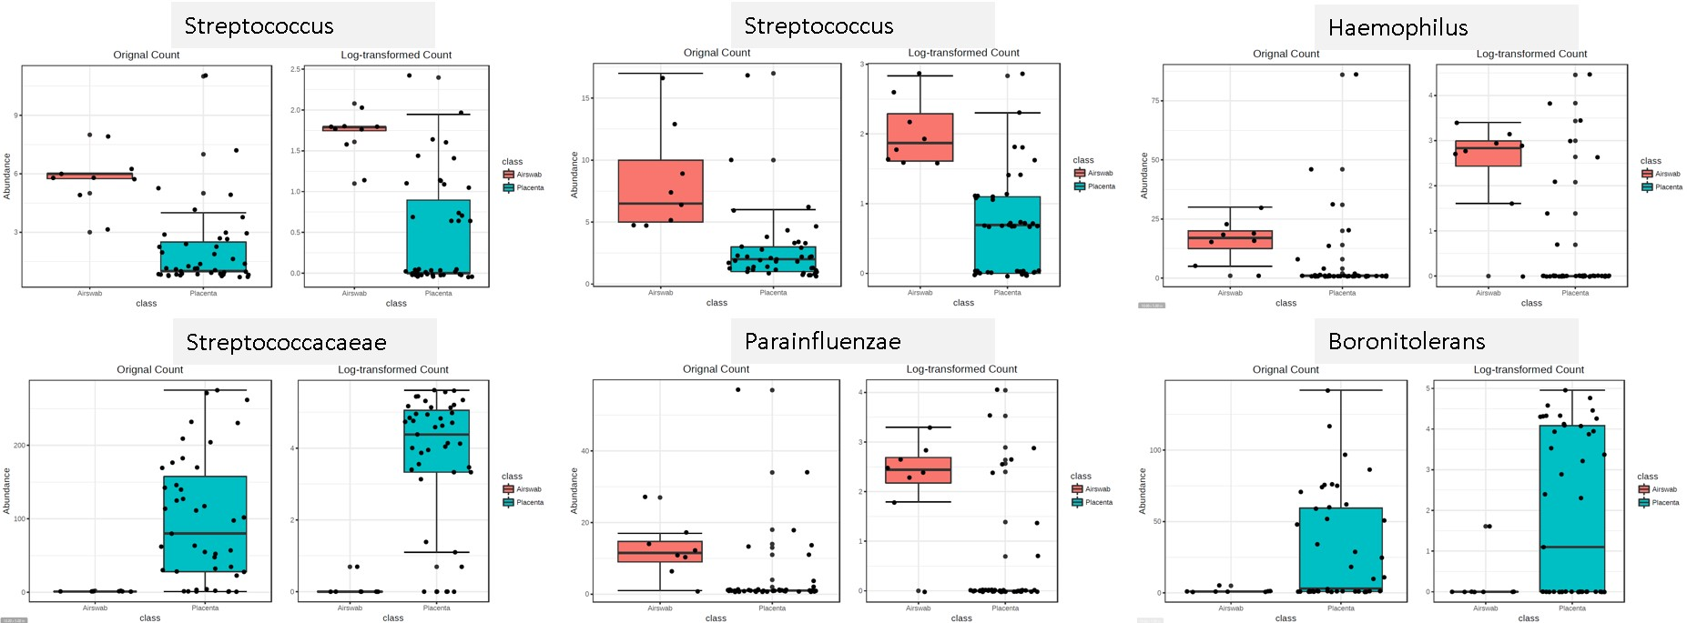

Figure 5: (A) Community structure in placenta compared to airswab samples. (B) Community structure in placenta (case, control separation) and airswab samples.
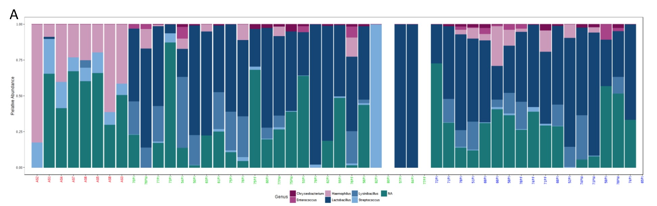
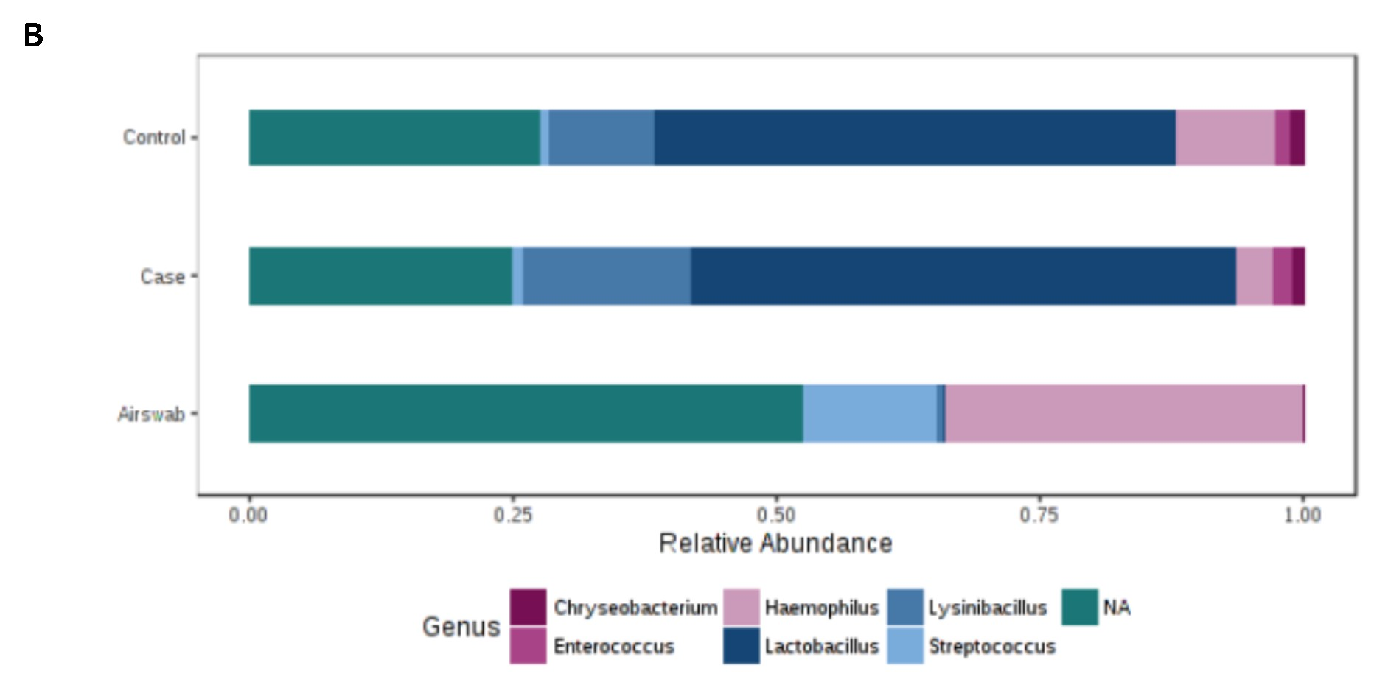

Figure 6: (A) PCA plot comparing obese and non-obese placenta samples. (B-C) Box-plot showing microbial diversity between obese and non-obese placenta samples (p=0.15837, ANOVA F-value=1.9154)

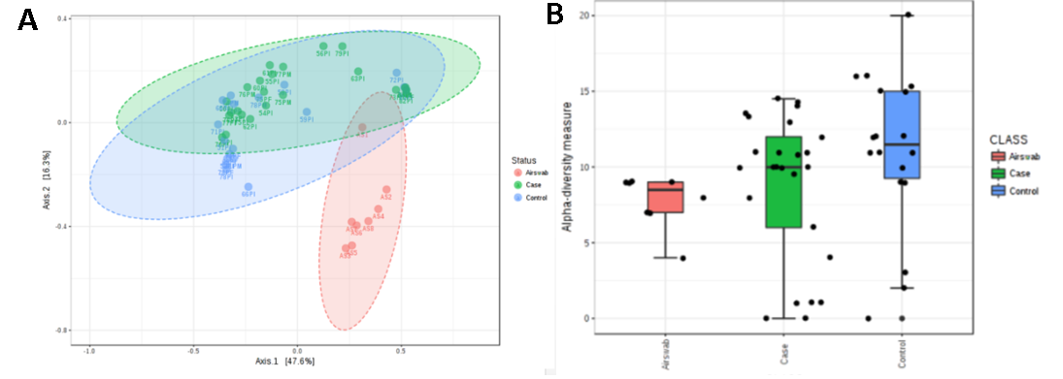

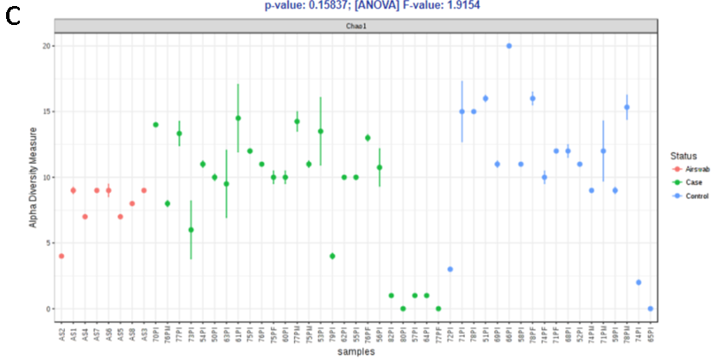

Figure 7: PCA plot of placenta samples obtained at different placenta locations (L1:maternal surface, L2:fetal surface, L3: intermediate surface) compared to airswabs (L0).

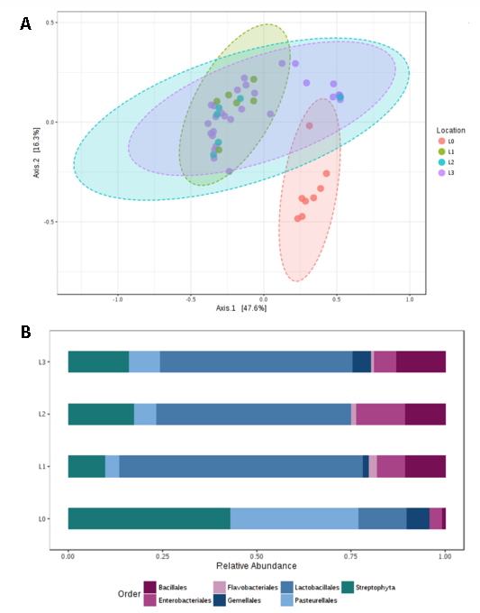

Supplementary Figure 1: Detailed bioinformatics pipeline used to analyze 16S reads in this study.

